National University of Computer and Emerging Sciences


Lab Manual
“Introduction to Data Modeling Tutorial Using Erwin”
Database Systems Lab
Spring 2023

Department of Computer Science
FAST-NU, Lahore, Pakistan

Table of Contents
1 Objective 2
2 Task Distribution 2
3 Introduction 3
4 Creation of a basic data model 3
5 Creating an Entity 5
6 Adding primary key columns 7
7 Creating Relationships 10
7.1 One-to-many Relationships 11
8 Generate a Data Dictionary Using Erwin 14
References 17

Objective
The object of this manual is to give an overview and hands-on practice to Data modeling using ERWIN

Task Distribution

Total Time
Demo and practice

Introduction
ERwin is a popular data modeling tool. The product supports a variety of aspects of database design, including data modeling, forward engineering (the creation of a database schema and physical database on the basis of a data model), and reverse engineering (the creation of a data model on the basis of an existing database) for a wide variety of relational DBMS. This brief tutorial steps you through the process of creating a data model using Erwin. Creation of a basic data model (Conceptual data model)

Creation of a basic data model
The Entities involved in this model include: Employee, Department.
From the File Menu choose to create a new model: File->New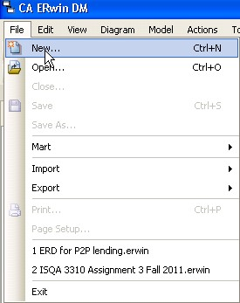
Figure 1: Create a new model
The next dialog box, shown in Figure 2, will ask you to choose the template to be used to create the new model. Choose Logical/Physical as the new model type. This choice will allow us to switch back and forth easily between a logical model (ER Diagram) and a physical model (database schema).
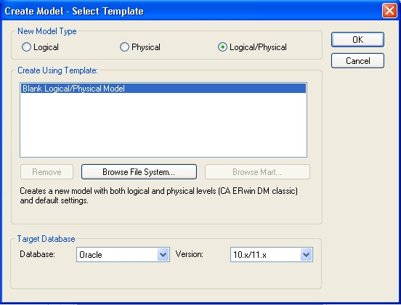
Figure 2: Selecting a model type
ERwin will now display the main window from which most of your ER diagram development will be done, as shown in Figure 3.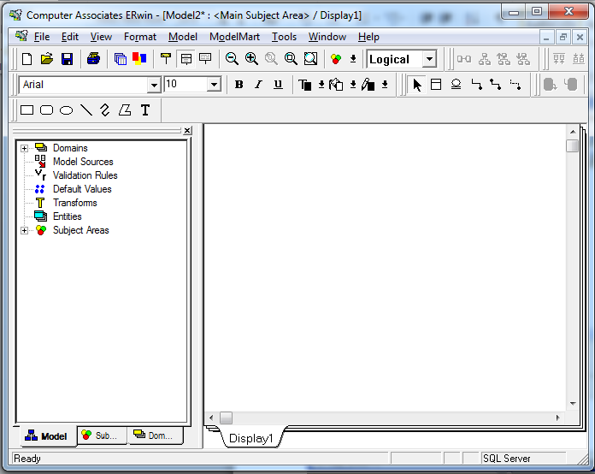
Figure 3: The ERwin Workplace
The ERwin workplace consists of two main parts. On the left is the Model Navigator, which displays a hierarchy of items of importance, such as entities, domains, and subject areas. On the right is the Display Window, which will show the ER diagram itself. As you create objects, they will appear in the display window (if they are visual in nature, like entities), and appear in the hierarchy within the Model Navigator.

Creating an Entity
To create a new entity, click on the entity icon () on the toolbar, or right-click on the word Entity in the Model Navigator. If you click on the entity icon, you then should click on the Display Window where you would like the entity to appear, as shown in Figure 4.
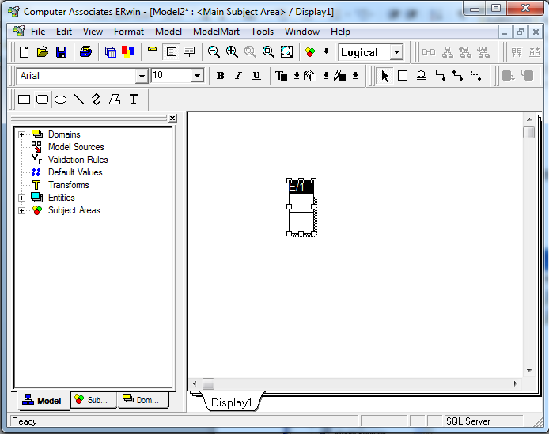
Figure 4: A new entity
Notice that the default name for the entity is E/x, where x is some number (1 in this case). Click on the Tab key several times and notice what happens. Pressing the tab key cause the focus to cycle between the three main parts of the Entity: the name of the entity, the primary key attribute(s), and the non-primary key attribute(s). In general, to modify one of these three parts of the entity, you will press the Tab key to cycle to the appropriate part of the entity, then type to add or modify that part of the entity.
Right now, press the Tab key until the entity name is highlighted. Then type EMPLOYEE, as shown in Figure 5.
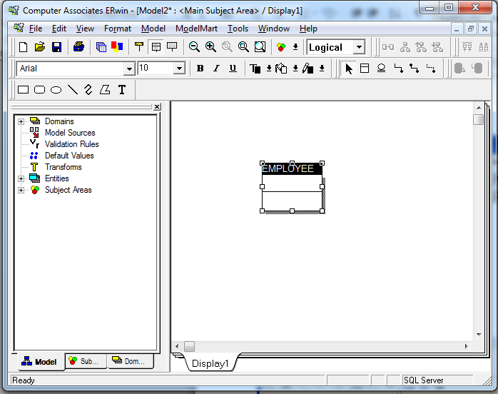
Figure 5: Changing the name of the entity
At this point, you may wish to save and name your diagram to avoid loss should the system or application crash.

Adding primary key columns
Once you have changed the name to EMPLOYEE, press the Tab key again to move the focus to the next part of the Entity, adding a primary key attribute. Then type the name of the primary key attribute, id, as shown in Figure 6.
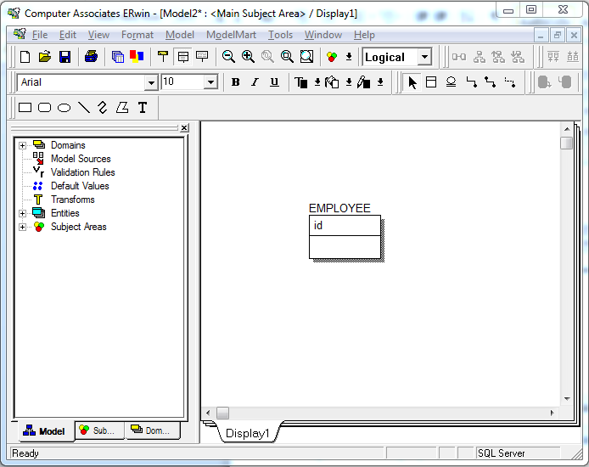
Figure 6: Adding a primary key attribute
Press the Tab key one more time to bring the focus below the horizontal line in the Entity, where you will add in a number of non-primary key attributes. Type fname, as shown in Figure 7. When you have typed fname, press the Enter key (not Tab). Notice what happens. The cursor is now positioned for you to add another attribute in this same portion of the Entity, the non-primary key attribute portion. Type another attribute lname.
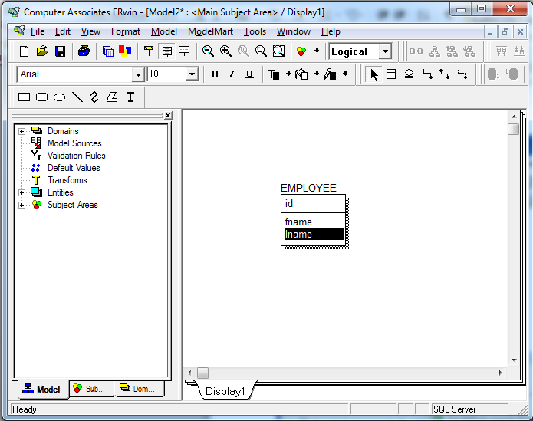
Figure 7: Adding non-primary key attributes

Make another entity, DEPARTMET with primary key dept_id and attributes name and city shown in the figure below.
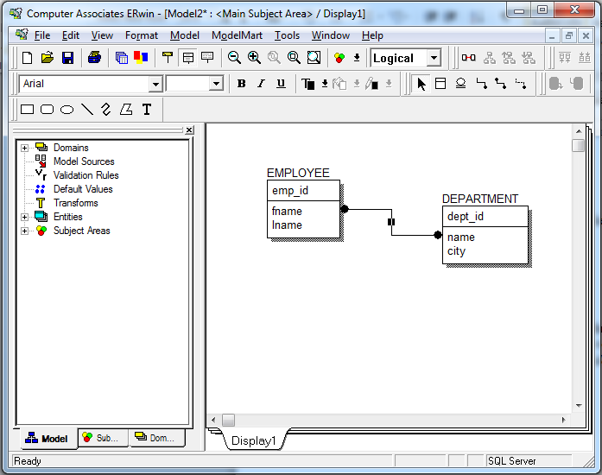
Figure 8: The Employee entity

Creating Relationships
ERwin supports the creation of relationships with three basic kinds of connectivity: one-to-one, one-to-many, and many-to-many. Within the one-to-many category, ERwin allows us to distinguish between identifying and non-identifying one-to-many relationships.
Q: What's the difference between identifying and non-identifying relationships?
- An identifying relationship is when the existence of a row in a child table depends on a row in a parent table. This may be confusing because it's common practice these days to create a pseudo key for a child table, but not make the foreign key to the parent part of the child's primary key. Formally, the "right" way to do this is to make the foreign key part of the child's primary key. But the logical relationship is that the child cannot exist without the parent.
Example: A Person has one or more phone numbers. If they had just one phone number, we could simply store it in a column of Person. Since we want to support multiple phone numbers, we make a second table PhoneNumbers, whose primary key includes the person_id referencing the Person table.
We may think of the phone number(s) as belonging to a person, even though they are modeled as attributes of a separate table. This is a strong clue that this is an identifying relationship (even if we don't literally include person_id in the primary key of PhoneNumbers).
- A non-identifying relationship is when the primary key attributes of the parent must not become primary key attributes of the child. A good example of this is a lookup table, such as a foreign key onPerson.state referencing the primary key of States.state. Person is a child table with respect to States. But a row in Person is not identified by its state attribute. I.e. state is not part of the primary key of Person.
A non-identifying relationship can be optional or mandatory, which means the foreign key column allows NULL or disallows NULL, respectively.

One-to-many Relationships
A non-identifying relationship is created by clicking first on the non-identifying relationship icon (). To create annon-identifying relationship, click first on this icon, then click on the parent entity (on the one side of the relationship) and then click on the child entity (on the many side of the relationship). In this case, you will click first on the non-identifying relationship icon, then on DEPARTMENT, then on EMPLOYEE. The results are shown in Figure 10.
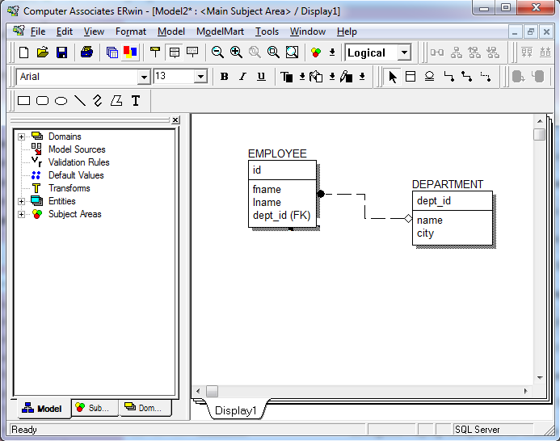
Figure 10: A non-identifying relationship
Double-click on the relationship itself to bring up a dialog box in which we can further refine the relationship definition. As shown in Figure 11.
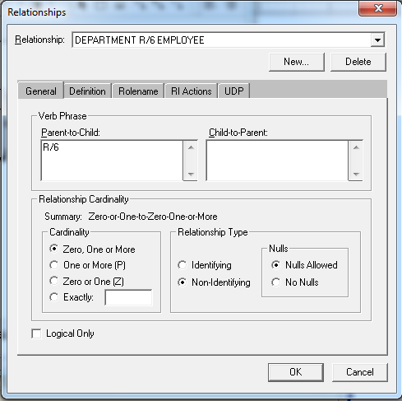
Figure 11: Relationships definition
In the Relationship Cardinality portion of this window, we can determine how many child entity occurrences may be associated with each parent entity occurrence.

Generate a Data Dictionary Using Erwin
Switch to logical view. Go to the Tools menu, choose Report Builder. Until the first template is saved in the Reports folder, you may see a message indicating that the folder is empty. Or you may see a message indicating that you need to click the Browse button on the next dialog and select a folder where you want to save your reports.
Click new to create a new report.
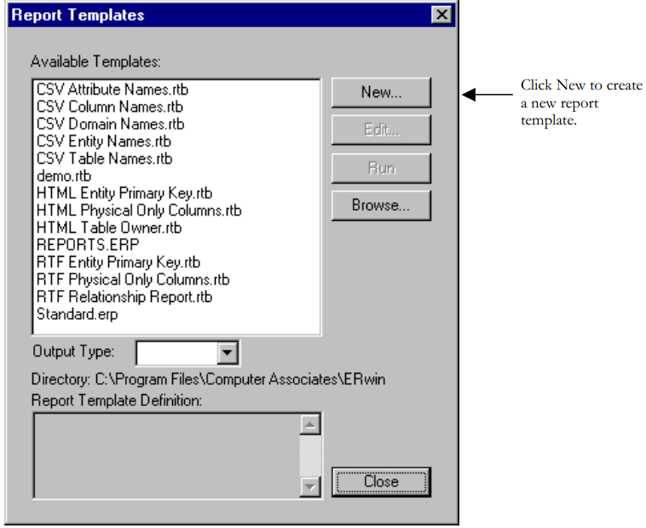
The dialog box as shown in figure 12 will pop up.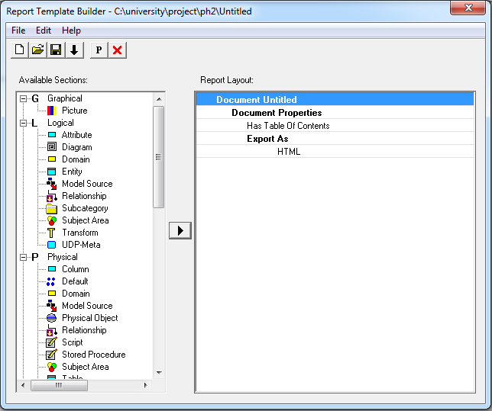
Figure 12: report template builder
You can select various options to build a report template which, can be explored in detail in the Erwin guide provided. You can export the document as HTML, RTF or text.
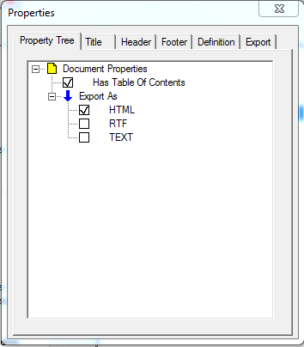
Select the Entity section from the right panel. We created two entities in the last section. We want to generate the data dictionaries for Data Model we created in the last section. Select the table and diagram sections from the right panel as shown in figure below.

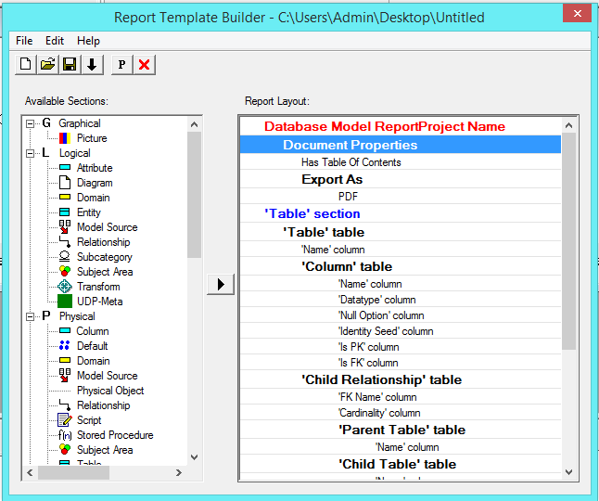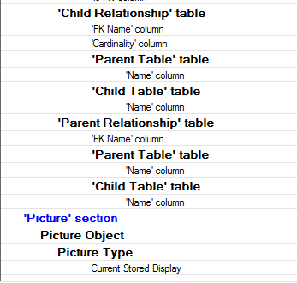

Now, Save your report template. Close the report template builder window.
Select the template you just created and click run to generate the data dictionary as Shown in the figure below.
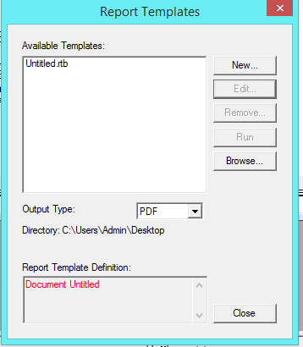

Select Output type as PDF. After clicking run, the generated report will get displayed as shown in file Reprt.pdf.

References

- http://stackoverflow.com/questions/762937/whats-the-difference-between-identifying-and-non-identifying-relationships

